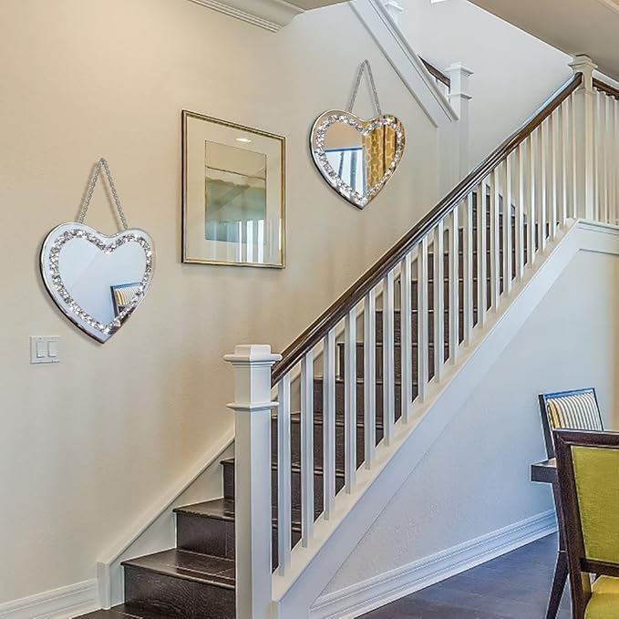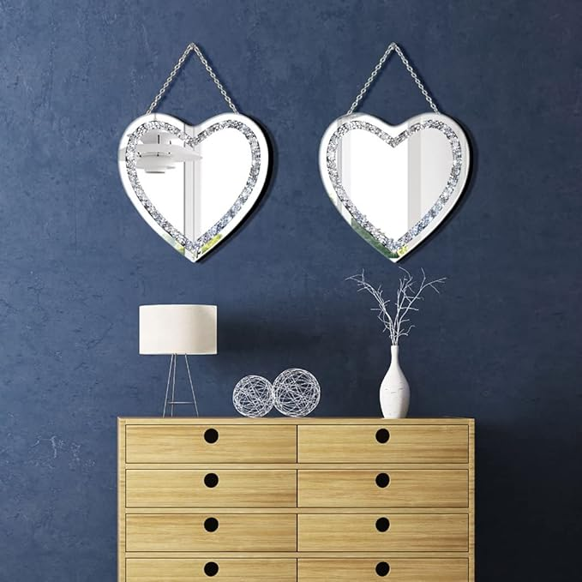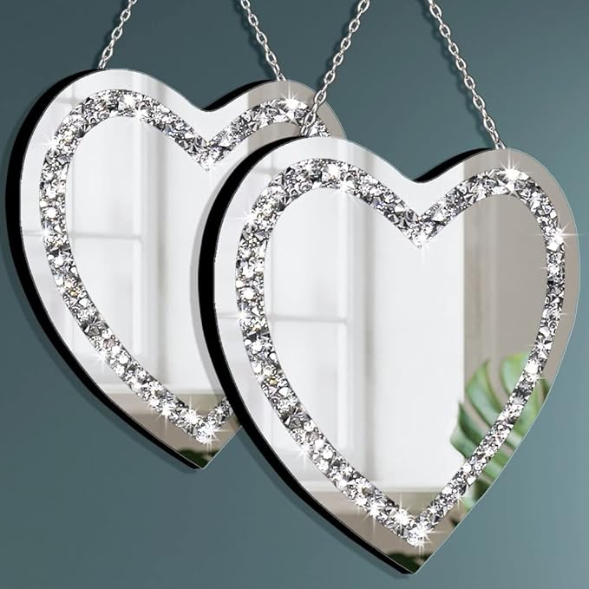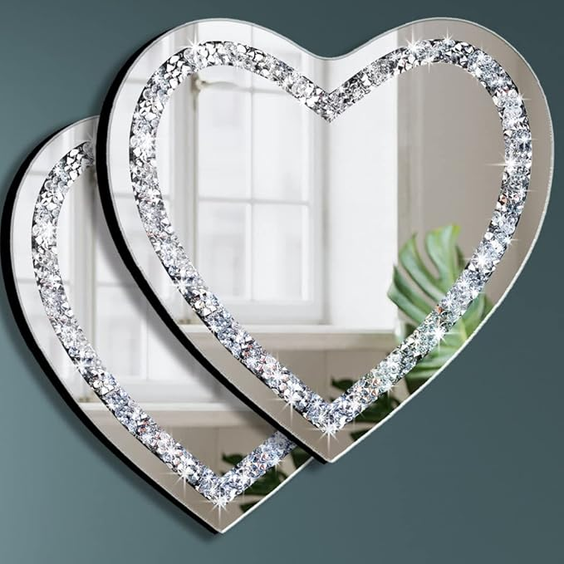

DMDFIRST Heart Shaped Silver Glass Mirror 2 Pack 12x12inch Crystal Crush Diamond Decor Chain Mirror for Wall Decoration

**PRODUCT DESCRIPTION:**

|  |  |
| --- | --- |
| Brand | DMDFIRST |
| Room Type | Bedroom |
| Shape | Heart |
| Product Dimensions | 12"L x 12"W |
| Frame Material | Engineered Wood |

**About this item**

* Product size: 12x12 inch, Thickness 0.5inch. Pack of 2 pieces. Heart Shaped frameless design with Sparkle Twinkle Bling Crystal Crush Diamond. Silver iron stainless steel chain wall decorative mirror. Glam mirror Classic design. 30x30cm
* Material: polished silver mirror with glass crystal crush diamond decoration, Silver stainless steel chain ready for wall Hang. The mirror is constructed by MDF wood back for reinforcement and stability.
* Frameless mirror design that can fit with different style of home decoration. Delicate mirror adds fashionable and elegant element for household, Bathroom, powder room Vanity, Bedroom, living room decorative mirror highlight your home.
* Easy to install. Silver iron stainless steel chain at the back, please hang the mirror stable strongly on the wall.
* After-sales service: If products received not satisfied, you can choose exchange or refund, welcome to contact us for any question. Hope you enjoy buying from us.